Test PE  
Spring 2023  
Subject: WED201c  
Duration: 120 minutes  
**Objectives:**

1. Create a style sheet and link it to the html file.
2. Create a file named yourCode.js and link it to the html file.

**Background:**

* In this practice exam, you are given a folder “**Resource**”. You are going to use page “index.html” to finish the exam. **You don’t be change image and not used framework Bootstrap.**
* After completing the final exam, The student will submit the **Resource folder** to the Server.

**Before styling index.html page**

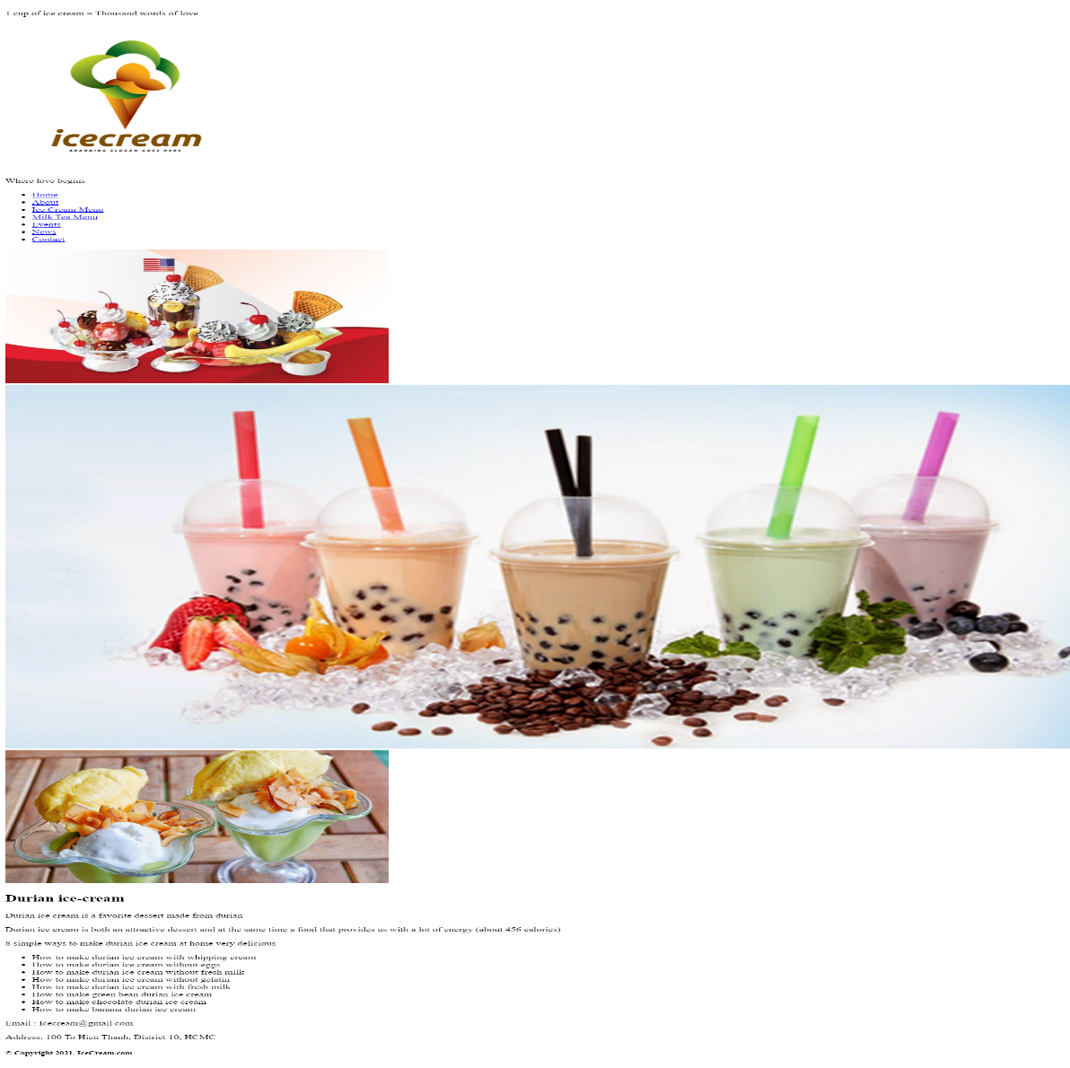

**After styling index.html page**

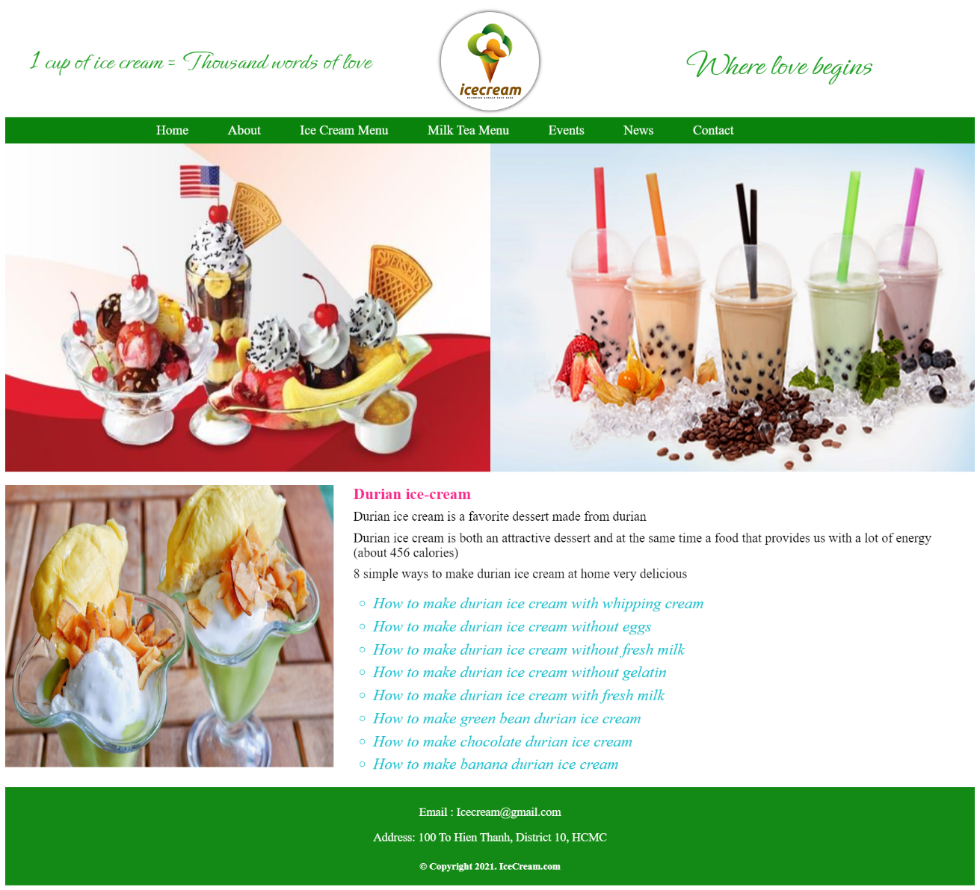

**Required:**

1. Create a file called styleindex.css to format the index.html page and save it to the **Resource/CSS folder**.
2. Create a file called “mycode.js” and save it to the **Resource/js folder**. You must link this file to the index.html page.

**Evaluation**

**A. HTML [2.5 points]**

* Embed the styleindex.css file in the head tag of the index.html page [0.5 points].
* Embed the mycode.js file at the end body tag of the index.html page [0.5 points].
* Insert html tags into the index.html page to display the content "IceCream & Milk Tea" as shown below [ 1.5 points] :

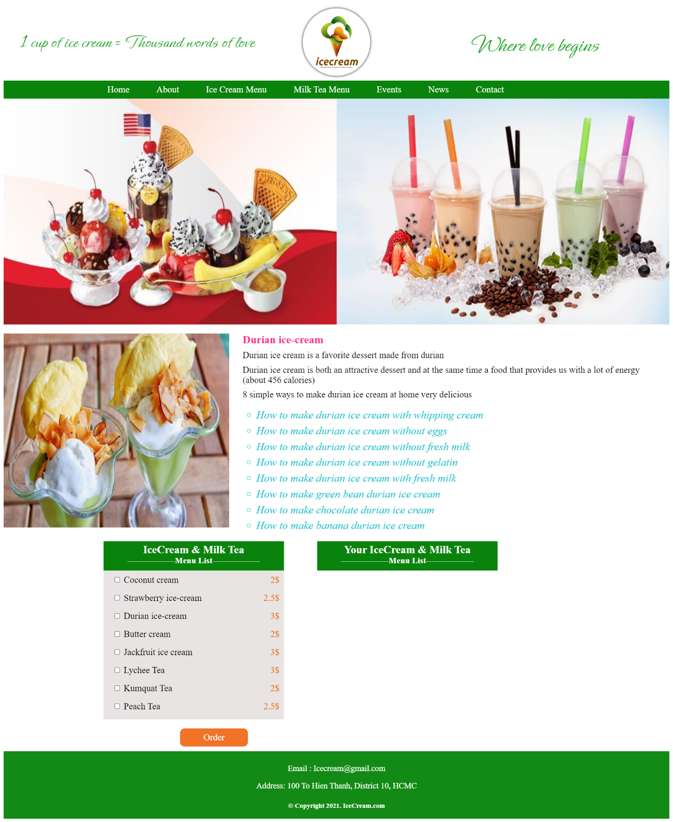

**B. CSS [ 6 points]**

* Use margin and padding to create the right spacing for the contents [1 point].
* Use css to format the menu as shown above [ 1 point].
* Use css to format the logo and Slogan as shown above [ 1 point].
* Use css to format the banner as shown above [ 0.5 points].
* Use color to format for the title and contents [1 point].
* Use css to format the content "IceCream & Milk Tea" [ 1 point].
* Use color and background to the “footer” content[ 0.5 points].

1. **Javascript [1.5 points]**

* Write a function called **CalTotal()** to calculate the Total amount for the IceCream and Milk Tea selected by the Customer . When the Customer clicks on the **Order** button, The list of Ice Cream, Milk Tea and Total amount will be displayed as shown below [ 1.5 points] :

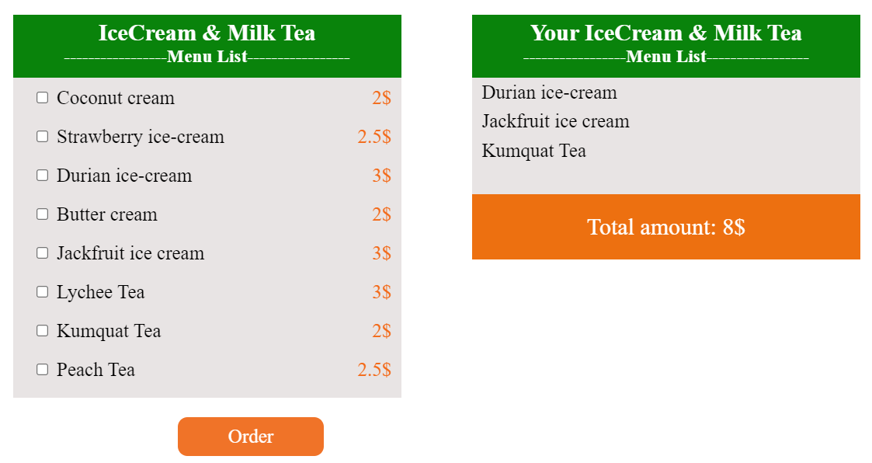

**The end**